- Problem 1:
  - Different results, I would like to explain:
In the main method:
Person p1 = new PersonWithJob("Joe", 30000);
Person p2 = new Person("Joe");
Two comparisons are made:
p1.equals(p2);
p2.equals(p1);

Comparation 1:

p1.equals(p2) => false. Because: p1 is an instance of PersonWithJob. So, the equals method in PersonWithJob is executed. This method checks:
if(!(aPerson instanceof PersonWithJob)) return false;
p2 is only a Person, not a PersonWithJob => condition fails => Result: false

Comparation 2:

p2.equals(p1) → true. Because: p2 is an instance of Person. So, the equals method in Person is executed. This method checks:
if(!(aPerson instanceof Person)) return false;

p1 is a PersonWithJob, which is a subclass of Person => condition passes. Then it compares names: both are "Joe" => equal => Result: true

  - A solution by replacing inheritance with composition:
    - New code: https://github.com/miunthphuong/MPP/tree/main/Assigment/Lab%203/Lab3%20-%20code/code%20for%20prob1/lesson3/labs/prob1

    - New Class Diagram:

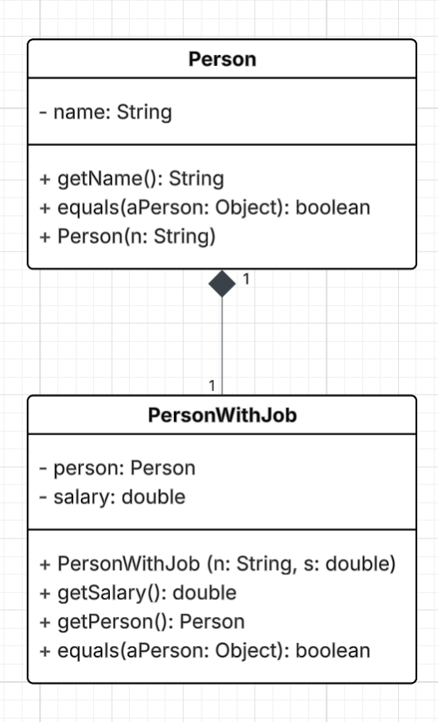

- Problem 2:

  - Solution with class diagram:
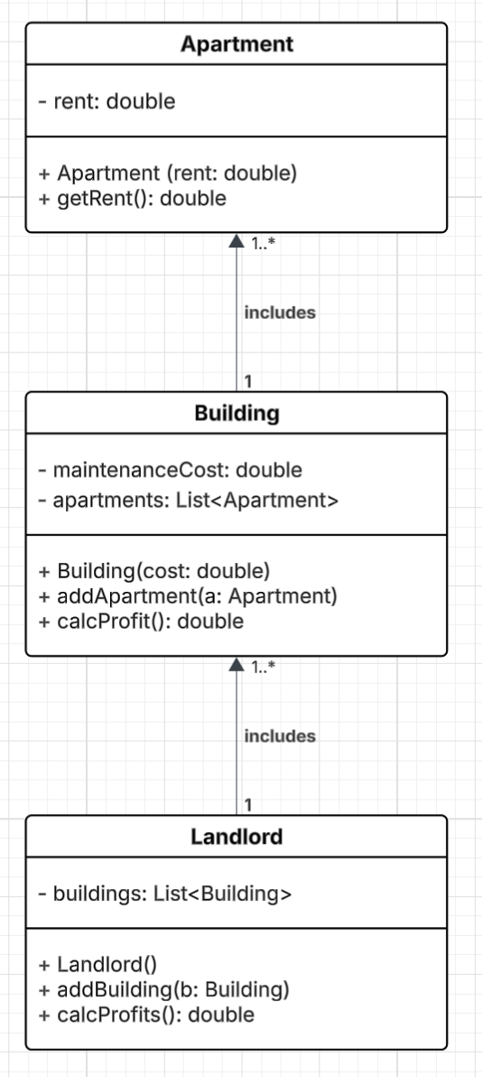
  - Source code: https://github.com/miunthphuong/MPP/tree/main/Assigment/Lab%203/Lab3%20-%20code/code%20for%20prob2

- Problem 3: The class diagram
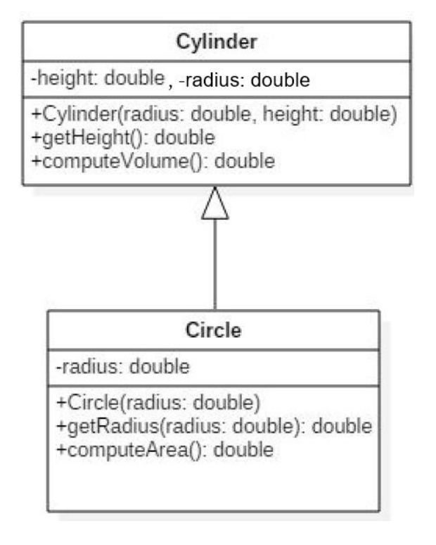

  - This inheritance in above class diagram does not make sense. Because Inheritance expresses an “is-a” relationship. So the diagram is saying: Cylinder is a Circle. That’s incorrect in object-oriented design. The real relationship: A cylinder is NOT a circle. Instead: A cylinder has a circular base. => This is a composition (has-a) relationship, not inheritance.

Source code: https://github.com/miunthphuong/MPP/tree/main/Assigment/Lab%203/Lab3%20-%20code/code%20for%20prob3/prob3-A/src

  - Using composition
Class diagram:
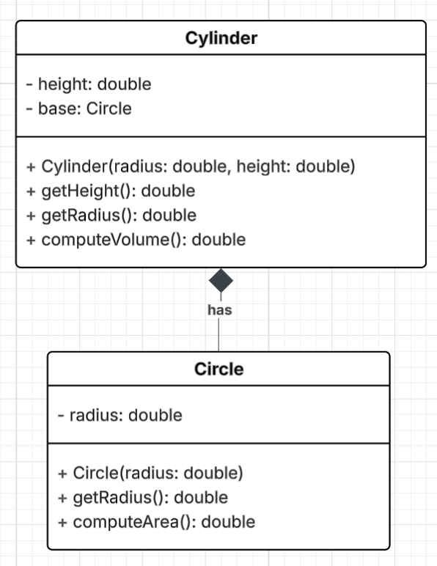

Source code: https://github.com/miunthphuong/MPP/tree/main/Assigment/Lab%203/Lab3%20-%20code/code%20for%20prob3/prob3-B/src
Source code:

- Problem 4:

